Student Experimental Farm Project and Activities Proposal Form
This document serves as a proposal for those who wish to do activities at the student experimental farm, and seeks to clarify proposed activity details. Before implementation can take place, projects must be approved, first, by identified SEF Faculty Facilitator (presently Dr. Pete Schwartz), and then by HCS Department Head (presently Dr. Scott Steinmaus), and Cal Poly Environmental Health and Safety.

SEF Mission Statement
Bringing the "old organic farm" back to life, we envision an interdisciplinary learning community dedicated to teaching, learning, practicing sustainability.

Project Title: Automated Vertical Farm

Statement of Project: Test the prototype of an autonomous aquaponic vertical farm.

Project Type: Please put an “X” in all appropriate boxes
[x] Senior Project [ ] Class Project [x] Independent Project [ ] Event [ ] Other (specify) ___________________
List name of advisors with contact information: Dr. Bo Liu. Bliu17@calpoly.edu
List Participants with Cal Poly affiliation (i.e., student, staff, none): Jacob Murphy

Project Location
On the map below, please find a red circle that you can change in size and location. Please adjust this circle so that it fully describes the areas you will plan to use. If you require more than one location, please make multiple copies of the circle.

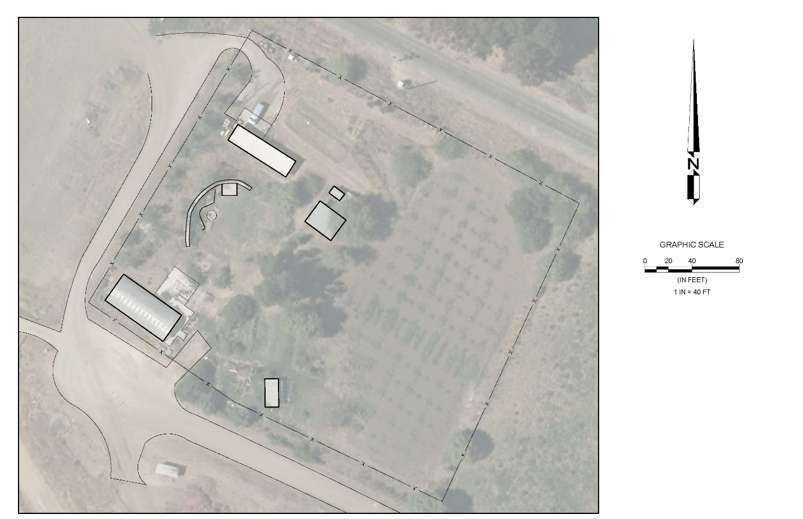

Please specify location details:
5 ft x 5 ft area on the concrete slab next to the green house.

Deliverables
What is the project or activity meant to achieve, create, or deliver?
Test a prototype of an automated vertical farm.

Project Details and Logistics
Please list all reasonably possible activities that will take place and refer to the Cal Poly Risk Management website and the guidelines listed in the Program Development Document to determine whether training, precautions, or supervision is required for any activities listed.
Regular site visits for maintenance and monitoring. Electrical equipment will be used.

Potential Hazards
Describe anything you can foresee that might threaten safety or property and what might be done to mitigate risk.
Electrical equipment malfunction. Little to no risk due to the small size of the machine.

Timing and Permanence
Over what period of time will the project or activity take place? Projects are limited to two years. If your project extends beyond this time period, you can extend it with another application.
Starting date: June 19, 2016.
Ending Date: December 20, 2016.
Can project be easily disassembled? If so, how and when will it be disassembled? What condition will the project be left in when project is finished? No project can use cement, concrete, or plaster without specific request and permission.
Project will rest on the existing concrete slab. All parts are fully disassembleable.

Funding
How is this project going to be funded? How is the work and cost of the project going to be supported? Please list funding sources and chances of success from each source.
System is already constructed. Only a location to test it is required.

Strategic Context
How does the project relate to SEF’s and Cal Poly’s missions?
This prototype will act to learn more about the possibility of automated vertical farming. The use of aquaponics in the system also falls within the sustainability portion of the SEF’s mission. The project also encompasses the learn-by-doing mission of cal poly.

Contract
By signing below, I Jacob Murphy hereby request consideration, acceptance, and approval of the above project/activity proposal. I am committed to complete the project/activity as outlined in the Guidelines for Projects and Activities of the SEF Development Document. I understand that if activity is not completed by end time as specified in this document I will need to resubmit this proposal. It is further understood that a revised activity project proposal may be necessary before approval.

Jacob Murphy
Signature

This project is approved for implementation upon approval, first by identified SEF Faculty Facilitator and then by HCS Department Head, (presently Pete Schwartz and Scott Steinmaus respectively) and then Cal Poly Risk Management
By signing below, I hereby approve this project for implementation.

_____________________________________
Pete Schwartz, SEF Faulty Facilitator

_____________________________________
Scott Steinmaus, HCS Department Head

_____________________________________
Cal Poly Risk Management Representative

